**Table1 –**

1. Write a SQL query to order records by a rental price  column in ascending order.

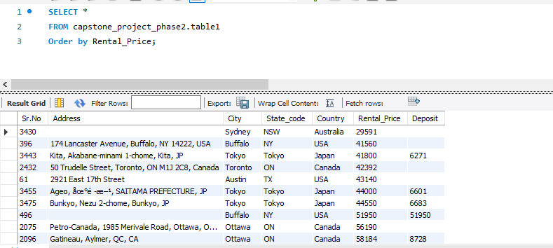

1. Write a SQL query  to select unique combinations of City and State with their average Rental Price.

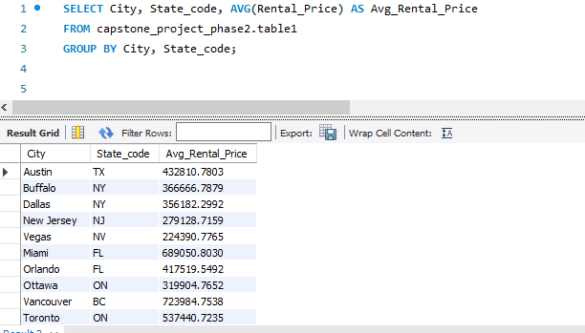

1. Write a SQL query to select the top 5 highest deposit amounts with corresponding Address and City .

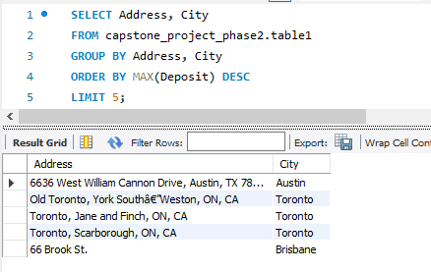

1. Write a SQL query to select the count of records for each Country along with the total deposit amount.

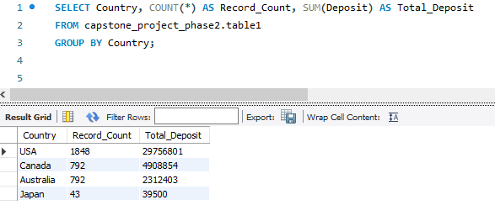

1. Write a SQL query to select records with a Rental Price higher than the average Rental Price across all records.

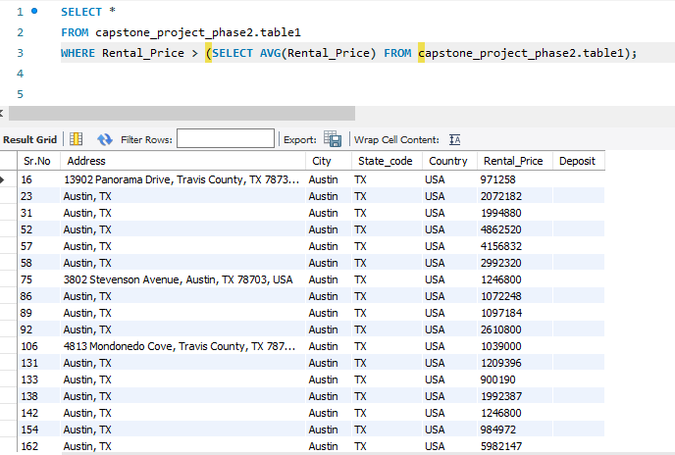

**Table2**

1. Write a SQL query to select the average area for each number of bedrooms.

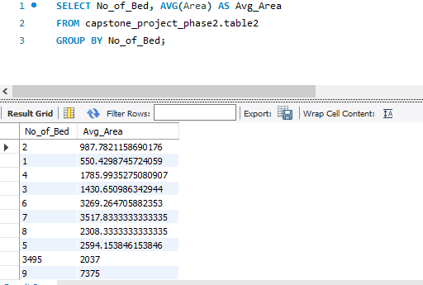

2)  Write a SQL query to select records with more than one bathroom and pets allowed.

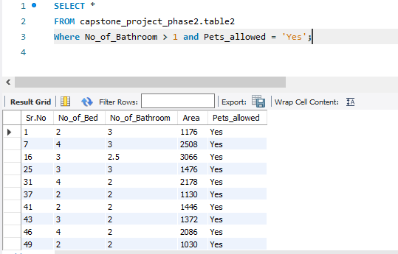

3)     Write a SQL query to select the top 3 records with the highest total area (bedrooms + bathrooms).

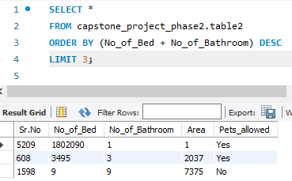

 4)     Write a SQL query to select the count of records for each combination of bedrooms and bathrooms.

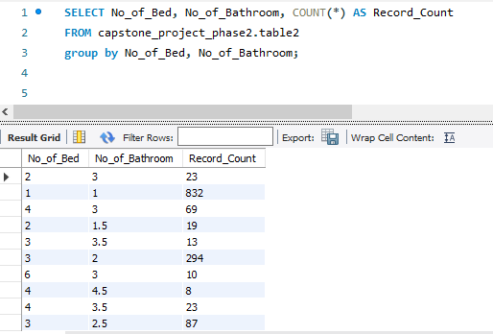

 5)      Write a SQL query to  select records with the largest area where pets are allowed .

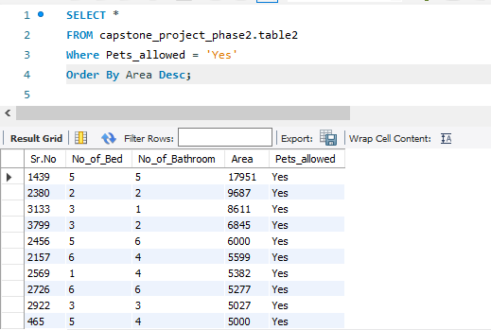

**Table3**

 1)     Write a SQL query to Select records where both Washer/Dryer and AC are available, and order by Sno.

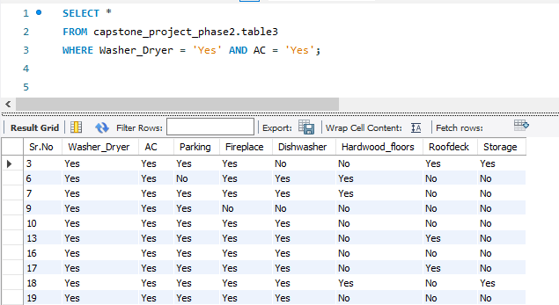

2)      Write a SQL query to Select records where Hardwood floors are available but neither Roofdeck nor Storage is present, and order by Sno in descending order.

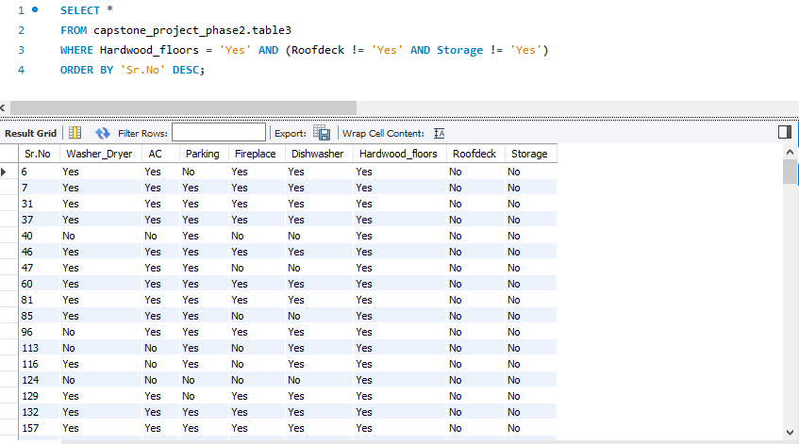

 3)     Write a SQL query to Select records where at least four amenities (AC, Parking, Dishwasher, Fireplace) are available, and order by Sno .

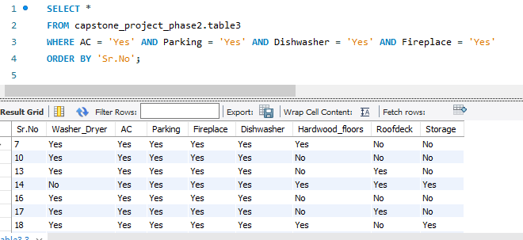

  4)     Write a SQL query to Select records where neither Roofdeck nor Storage is available, and include the count of such records.

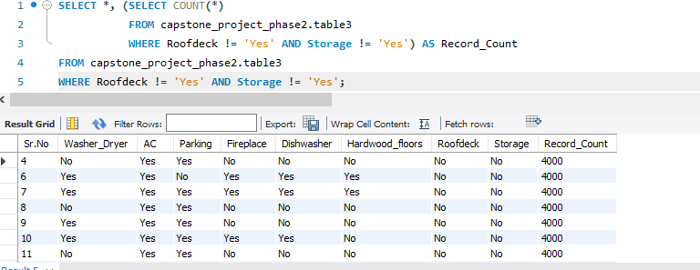

5)     Write a SQL query to Select records with Parking and either Fireplace or Dishwasher, and include the count of records for each condition.

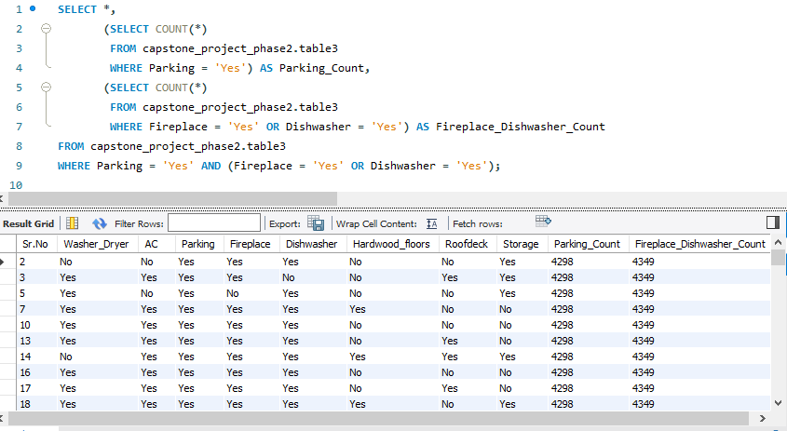

**7  Join SQL Queries  using all 3 tables**

1)     Write a SQL  subquery to find records with more than the average area and related details using table 1 and table 2.

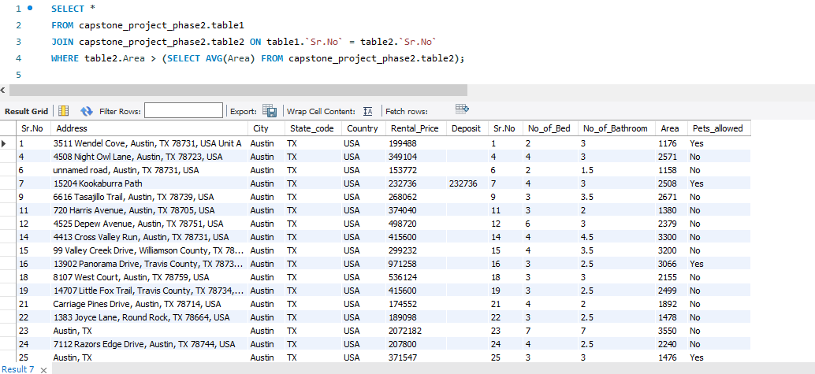

2)     Write a subquery to find records in table1 based on conditions pets allowed is ‘YES’  and no of bed is greater than 3   in table2.

3)        Write a SQL    subquery using both tables (2 and 3) to find records in Table2 with more than 2 bedrooms and related details from Table3 where AC is present .

4)      Write a sql subquery  to find records in Table2 with pets allowed and a Dishwasher, and include related details from Table3.

5)      Write a subquery  to find records in Table2 with the highest area and related details from Table3 where roofdeck is present.

6)     Write a sql  Inner Join to combine information from table1 and table 2.

 7)     Write SQL  Subquery to find records in table1 with pets allowed and a Washer/Dryer, and include details from table2 and table3  .